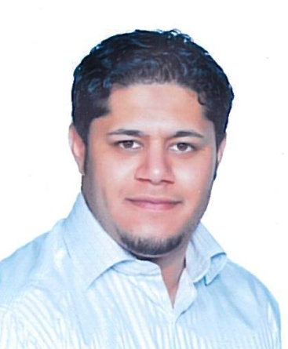Name : Majeed .a. Hussain Salman

Nationality: Bahraini

Marital status : married

Date of birth: 20-06-1987

Adders: Flat 11 Building 1710- road 5054-shakhoora 450

C.p.r. no :870604597

Passport No.: 1867825

Contact no: 39778699/39778677

Education& qualifications:

Primary abu saiba boys school graduated on (1999)

Al sehla secondary boys school graduated on (2002)

Ahmad AL omran boys high school (2003) not graduated

Languages :

Arabic : writing , reading and speaking

English :little speaking

Indian : speaking

Languages :

Fakhrawi book shop: sales man (2003)

National motor company w.l.l : driver (2004-2005)

Al turk mechanical and industrial co. : driver(2006)

driver (6 months royan :

Kazroni construction company : driver (2007-2008)

Awal press :driver (2009-2010-2011)

Vibrant security & services ( 2011- 2012 )

Speed time security (2012-2013

Additional skills:

Computer ms word , excel , internet and good analytical

Good public , communication skills

Interests :

Paling foot ball

Swimming

Cars driving